To: | Cabinet
Date: | 19 November 2025
Report of: | Group Finance Director
Title of Report: | Treasury Management Annual Report 2024/25

Summary and recommendations
Decision being taken: | The report sets out the Council’s Treasury Management activity and performance for the financial year 2024/25, (including any prudential borrowing limits which are in line with the capital programme and proposed financing), in line with requirements from CIPFA’s code of practice.
Key decision: | No
Cabinet Member: | Councillor Ed Turner (Cabinet Member for Finance and Assets)
Corporate Priority: | All
Policy Framework: | Treasury Management Strategy

Recommendation(s): That Cabinet resolves to:
1. | Note the Treasury Management Annual Report for 2024/25 and the Council’s compliance with the Prudential and Treasury Indicators.

Appendix No. | Appendix Title | Exempt from Publication
Appendix 1 | Risk Register | - No

Introduction and background
- The primary principle governing the Council’s investment decisions is the security of the investment, with liquidity and yield being secondary considerations.
- The Council has a statutory duty to set, monitor and report on its prudential indicators in accordance with the Prudential Code, which aims to ensure that the capital investment plans of local authorities are affordable, prudent and sustainable.
- When considering whether to borrow, the Council’s Debt Strategy requires a number of factors to be considered. These include:
    - prevailing interest rates;
    - the profile of the Council’s debt portfolio;
    - the type of asset being financed; and
  - the availability of cash balances to finance capital expenditure.

- The Council fully complied with its Treasury Management Strategy in relation to both debt and investment management in 2024/25.
- The prudential indicators detailed in the body of this report compare the Council’s outturn position against the target set for 2024/25

Executive Summary
- The Council held investments of £19.349 million (based on the investment value) as at 31st March 2025. Net interest earned during the year, including from loans to the Council’s companies and external borrowing, was a net £4.21 million against a target of £4.96 million, an adverse variance of £0.75 million. This is due to the use of internal borrowing. The overall outturn position for treasury transactions during the year was a favourable variance of £2.63 million. The position for the general fund can be broken down as follows:
Favourable
- Borrowing costs lower by £1.52 million due to long term borrowing on the General Fund not being required, following slippage in the capital programme including lower loan requirements from the Council’s housing companies.
- £0.77 million interest charged to the Housing Revenue Account (HRA) in lieu of external borrowing
- £0.50 million lower payment to the HRA for cash balances due to the use of HRA balances being used for capital financing before borrowing
- Minimum Revenue Provision charges lower by £0.59 million due to lower general fund borrowing and only financing repayable loans or schemes with a long life from borrowing;
Adverse
- £0.61 million lower interest income from the Council’s companies due to slippage in loans to the Council’s housing development company and the Barton Properties now transferring into the HRA
- £0.14 million less general investment interest due to lower cash balances following the use of resources for internal borrowing
- The average rate of return on the Council’s investments in 2024/25 was 4.97% compared to 4.52% in 2023/24. The Bank of England base Rate decreased steadily in the later part of 2024/25, starting at 5.25% and finishing at 4.50%.
- The Council held £288.528 million of fixed rate Public Works Loan Board (PWLB) debt as at 31st March 2024. £198.528 million was originally borrowed in March 2012 to fund the self-financing of the HRA with one of the loans that had matured being replaced on 28th March 2022. Additional debt was taken out in 2023/24 of £20 million and an additional £70 million has been borrowed in 2024/25 to replace internal borrowing taken out by the HRA in order to replace cashflow resources. All of the debt relates to the Council’s housing function and the maturity profile ranges from 5 to 50 years. Interest paid on the debt in 2024/25 and charged to the HRA was £6.40 million.

Financing the Capital Programme 2024/25
Table 1 below shows actual capital expenditure and expected financing compared to the original budget.
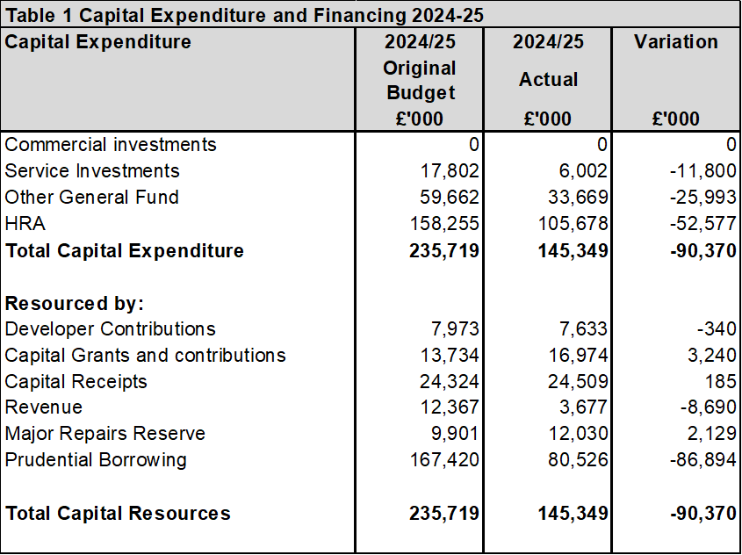
Much of the variation to the original budget relates to slippage in the programme, the resources for which will be moved into funding the expenditure in future financial years.

The Council’s Overall Borrowing Need
The Council’s underlying need to borrow, or Capital Financing Requirement (CFR), is the measurement and control of the Council’s overall debt position. It represents all prior years’ net capital expenditure which has not been financed by other means, i.e. revenue, capital receipts, grants etc.
The CFR can be reduced by:
  - The application of additional capital resources, such as unapplied capital receipts;
  - Repayment of debt financed by borrowing (including repayment of capital debtors); or
  - Charging a Minimum Revenue Provision (MRP), or a Voluntary Revenue Provision (VRP).
Table 2 below shows the Council’s CFR as at the 31st March 2025, this is a key prudential indicator, and shows that actual borrowing is below the CFR:
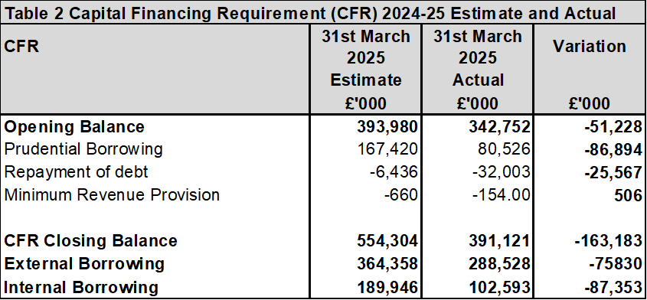
New external debt of £70 million was taken out during 2024/25 in relation to HRA capital financing and as at 31st March 2025 the Council’s total external debt is now £288.528 million, all in relation to the HRA. This is below the CFR and indicates that the Council continues to internally borrow from its cash balances which is the cheapest form of borrowing.

Treasury Position at 31st March 2025
Whilst the Council’s gauge of its underlying need to borrow is the CFR, the treasury function manages the Council’s actual need to borrow by either:
  - Borrowing to the CFR;
  - Choosing to utilise temporary cash flow funds, instead of borrowing (known as “under borrowing”); or
  - Borrowing for future increases in the CFR that are reasonably certain

The Council’s treasury position as at the 31st March 2025 for both debt and investments, compared with the previous year is set out in Table 3 below:

Overall, the Council earned a weighted average return of 4.97% on its investment which is higher than our internal target of 0.1% above the average bank base rate of a weighted average of 4.75% in the year to 31st March 2025.

Prudential Indicators and Compliance Issues
Some of the prudential indicators provide an overview, others a specific limit on treasury activity. These are detailed below:
Net Borrowing and the CFR – In order to ensure that borrowing levels are prudent, the Council’s external borrowing (net of investments) over the medium-term must only be for a capital purpose, and not exceed the CFR except in the short-term. In the short term the Council can borrow for cash flow purposes. Table 4 below highlights the Council’s net borrowing position against the CFR, and shows that it is significantly below the limit, due to the level of internal borrowing that has been undertaken.

In the current climate, internal borrowing is still preferable to borrowing externally as the interest rate payable on an external loan is much higher than that which can be earnt on investments. Therefore, forfeiting interest receivable on investments is more economical than paying additional interest charges for new external debt. If the net borrowing position, interest rate position and/or CFR changed significantly, the prospect of taking on additional debt would be reviewed.
The Authorised Limit – The Authorised Limit is the ‘affordable borrowing limit’ required by section 3 of the Local Government Act 2003. The Council does not have the power to borrow above this level unless it explicitly agrees to do so. Table 5 below demonstrates that during 2024/25 the Council’s gross borrowing was within its Authorised Limit. The Authorised Limit allows for some headroom above the Council’s projected CFR.

The Operational Boundary Limit – the Operational Boundary Limit is the expected borrowing position of the Council during the year. It is possible to exceed the Operational Boundary Limit, for a short period of time, providing that the Authorised Borrowing Limit is not breached. Table 6 below shows the limits for the last two financial years. Actual borrowing increased by £70 million to £288.5m but the limits were not breached during either period.

Investment Income
High inflation put pressure on the Bank of England to increase the interest rate to reduce the rate of inflation. The rate rose to a peak of 5.25% and was not reduced until 1st August 2024 to 5.0%. The Council manages its investments in-house and invests with institutions listed in the Council’s approved counterparty list. The Council generally invests for a range of periods from overnight to 364 days, dependant on cash flow requirements and its view on interest rates and duration limits set out in the Council’s Investment Strategy which is within the Treasury Management Strategy 2024/25. Due to the use of internal resources to internally borrow to fund the capital programme, most of the council’s balances are invested in money market funds which are instant call.
During 2024/25, the Council maintained an average investment balance of £34.1m million and received a weighted average return of 4.97%. The upper limit of non-specified investments allowed in the strategy is 25% of the average investment balance for the preceding calendar year or £25 million, whichever is the higher. The average balance for 2023/4 was £59.7 million giving a limit on non-specified investments of £25 million. Property funds and Multi Asset Funds fall into the non-specified investment category; their original investment value was £20 million which is within the non-specified limit of £25m Limit
The property funds and the Multi asset Funds are classified as Non-specified Investments within the approved Investment Strategy. The weighted average rate of return on the pooled investments in the year to 31st March 2025 was circa 4.92% per annum.
The capital value of the Communities, Churches and Local Authorities (CCLA) Fund has increased by 22.61% between April 2013 and March 2025. The Lothbury investment has been closed and we are receiving capital repayments back as assets are disposed of. As at the 31st March 2025, £6.181 million of our initial £7 million investment had been redeemed at a value of £5.427 million, a loss of £0.754 million on the initial investment value. It is estimate that there will be a £0.854 million capital loss overall once all of the remaining funds are returned. This is mitigated by an earmarked reserve being held to cover this risk. It should also be noted that the Lothbury Property Fund investment has returned £2.16 million which is around £0.8 million above the prevailing interest rate.
Two Multi Asset Funds each for the amount of £5m are held with two fund managers, Fidelity and Artemis. The values as at 31st March 2025 were £4.00 million and £5.67 million respectively. The position on both continues to fluctuate. As with the property funds any gains or losses should be considered over the long term. Aggregate Multi Asset Fund Investment value is currently approximately 3.2% lower than the original investment amount. It is expected that this will improve as bank interest rates fall further.
Fund managers are reporting that the funds continue to deliver stable income in line with objectives. Yields across asset classes have risen materially and have been incorporating higher yield investments- in the fund, which will remain the focus over the coming months. The funds are well positioned to continue to deliver objectives of a stable yield of around 4-6% per annum over a market cycle.
Treasury investment income for 2024/25 was £1.41 million; £0.14 million lower than the estimate of £1.55 million. This has to be seen in context of the overall treasury management activity due to internal borrowing replacing external investment resulting in savings in borrowing costs. Overall, the treasury activity in 2024/25 resulted in a favourable variance to budget of £2.6 million which is broken down in paragraph 1 of this report.
Fluctuations in the Council’s balances have been managed through a mix of instant access and notice accounts, money market funds and short term deposits (up to 364 days). This approach is in line with the Investment Strategy approved by the Council.

Other Loans
The Council currently have non treasury loans to its Oxford City Housing group of companies (known as OxPlace) of £8.4 million with interest rates varying in line with PWLB rates plus a subsidy control markup and £13.54 million to Oxwed LLP with an interest rate up to the end of 2024/25 of 6.5% per annum. There are also 2 loans with the Low Carbon Hub of £1.80 million with an interest rate of 2.85% and £1.82 million with an interest rate of 1.45%.

Treasury Advisers
The Council takes advice from MUFG (previously Link Asset Services) on the appropriate durations to place investments with counterparties. These durations and also the availability of individual counterparties are subject to change dependant on market conditions and the credit ratings of the individual institutions. This means that the investment portfolio has to be actively managed to ensure both the availability of enough suitable counterparties and that the Council achieves the best interest rates possible within the agreed security and liquidity parameters.

Interest Rates since 31st March 2025 and forecasts
Interest rates have been falling through 2024/25 finishing at a 4.5% base rate at the end of the year and forecasts suggested further gradual falls in short, medium and longer-term rates during 2025/26 and onwards. The current base rate is 4%.
The Consumer Price Index (CPI) measure of inflation was 3.8% in September 2025 and is expected to fall back to 2.1% over time.
The Council continues to use money market funds and instant access accounts for liquidity purposes, whilst seeking to maximise its returns by arranging longer term deposits where possible, it is vital to maintain a robust cash-flow model which is continuously reviewed and updated.

Environmental Social and Governance (ESG)
The Council adopted an ethical investment policy in 2015/16. No changes were made to the policy in setting the 2024/25 Treasury Management Strategy which is set out below:
The Council will not knowingly invest directly in businesses whose activities and practices pose a risk of serious harm to individuals or groups, or whose activities are inconsistent with the Council’s mission and values. This would include, inter alia, avoiding direct investment in institutions with material links to:

  - Human rights abuse (e.g. child labour, political oppression)
  - Environmentally harmful activities (e.g. pollutants, destruction of habitat, fossil fuels)
  - Socially harmful activities (e.g. tobacco, gambling)

The Council set a separate ESG policy within the 2023/24 Treasury Strategy which was then updated in the 2024/25 Treasury Strategy. ESG criteria are a set of measures of a company’s operations that socially conscious investors can use to inform potential investments. Environmental criteria consider how a company performs as a steward of nature. Social criteria examine how it manages relationships with employees, suppliers, customers, and the communities where it operates. Governance deals with a company’s leadership, executive pay, audits, internal controls, and shareholder rights. Due to the number of different agencies producing ESG data, which are not comparable between the agencies because of the different methodologies used, the Council is limited on how this information can be used to inform investment decisions. Due to the focus that has to be placed on the treasury management principles of Security, Liquidity and Yield, caution needs to be applied in order to not restrict the number of counterparties that the Council can invest in such that there is no remaining capacity for further investments or so that the level of interest income is not significantly affected which would cause unexpected financial pressure on the Council. However, the Council does monitor the activities of its various counterparties and questions and challenges them on their ESG credentials at any meeting held with them.

Financial implications
These are set out within the body of the report.

Legal Issues
The Council is required by regulations issued under the Local Government Act 2003 specifically the Local Authorities (Capital Finance and Accounting) (England) Regulations 2003 and guidance from CIPFA, to produce an annual treasury management review of activities and the actual prudential and treasury indicators for 2024/25. This report meets the requirements of both the CIPFA Code of Practice on Treasury Management (2021) (the Code), and the CIPFA Prudential Code for Capital Finance in Local Authorities, (the Prudential Code).

Level of risk
The risk register is attached at Appendix 1.

Equalities impact
The Council follows an ethical investment policy, investment interest helps provide council services, which has a beneficial equalities impact.

Report author | Bill Lewis
Job title | Financial Accounting Manager
Service area or department | Financial Services
Telephone | 01865 252607
e-mail | blewis@oxford.gov.uk

